TECHNICAL SPECIFICATIONS OF THE EQUIPMENT FOR 40 POSTS FROM HEALTH
PHOTOS
just an indication
Item No. | Technical specifications | Quantity
1 | TABLE REVIEW |  | 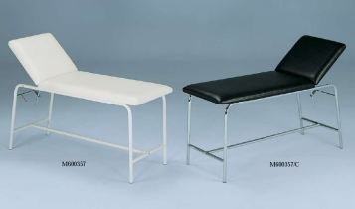
1 | composed of two parts which one recliner.
1 | With minimum thickness 12cm foam mattress, fabric cover plastic type resistant and washable leatherette | 40
1 | -Maximum range: 200 kg.
1 | -Dimensions: L 190 x 70 x h 80 cm
2 | SCREEN 3 SECTIONS |  | 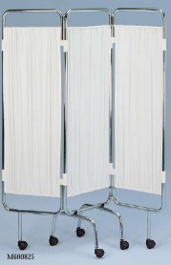
2 | -Isolation of patients in the delivery room or care.  -Metal steel frame, supporting a tense opaque fabric.  -Stable base.  -Dimensions: (L) 60 cm x 3, h 200 cm. | 120
3 | LADDER 2 MARKETS  aluminum alloy, anti. Dim: 40 x 20 x 46h cm | 120 | 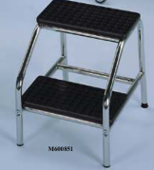
4 | SCALE WEIGHS 150 KG PERSON skid |  | 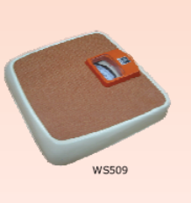
4 | · Model dial needle, solid metal construction. | 80
4 | · Covered deck with a non-slip mat.
4 | · Capacity 150 Kg per 100 g
5 | BALANCE BABY CURSOR 15 KG | 80 | 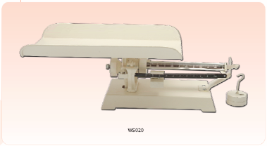
5 | · CE marking.
5 | · Table model, clinical type.
5 | · Scope 15 kg per 100 gr.
5 | · 2 cursors: kg, and gr
5 | equipped with a locking system
6 | BALANCE BABY HAS SUSPENDED DIAL |  | 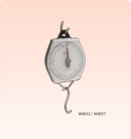  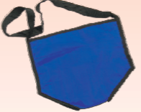
6 | Balance suspendue12 kg per 500 g type Salter, supplied with 5 weighing pants. | 80
7 | FLASHLIGHT PEN | 40 | 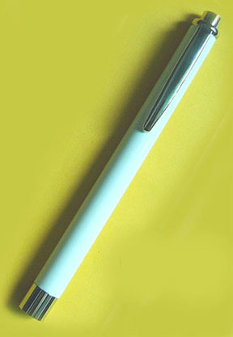
7 | -For 2 standard batteries 1.5 V
7 | -Supplied with 3 bulbs.
8 | A STAINLESS STEEL PEDAL BIN |  | 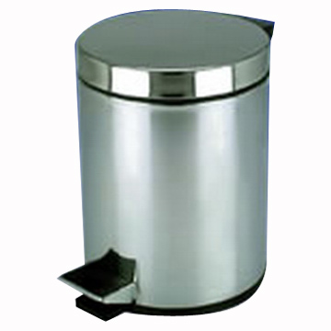
8 | -Body and cover in stainless steel with gasket. | 160
8 | -Opening by protected pedal.
8 | about 15 to 20 L
9 | A REFLEX HAMMER | 40 | 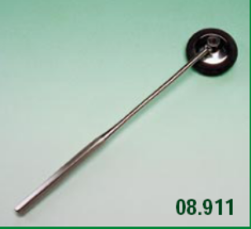
10 | OTOSCOPE | 40 | 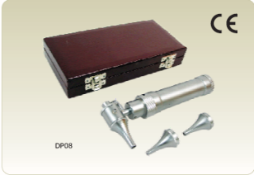
10 | -Delivered in a box.
10 | -Channel 2 batteries 1.5 v battery
10 | -Head and independent handle.
10 | -5 reusable specula (ear and nasal).
10 | -Delivered with 2 bulbs from spare parts and 2 batteries 1.5 v
11 | Blood pressure monitor + stethoscope |  | 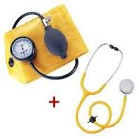
11 | -Armbands adhesive velcro adult and child, with pear. | 80
11 | – Pressure gauge blade, graduated from 0 to 300 mmHg to free needle.
11 | -Reset button.
11 | Delivered with a PEAR, 1 adult and child armband and 2 rubber tourniquets
12 | THERMOMETER, CASE |  | 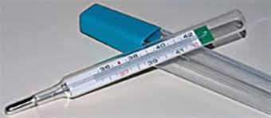
12 | medical thermometer | 40
13 | STOOL |  | 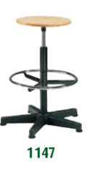
13 | -Height stool fixed 50 cm. | 80
13 | -Without folder.
14 | TABLE OF DELIVERY MANUAL | 80 | 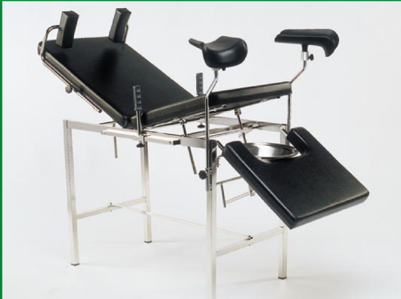
14 | -Simple model, easy to clean
14 | -Tubular frame in stainless steel or coated with epoxy paint, fixed base, protective rubber caps
14 | -Mattress thickness 12 cm minimum width 70 cm, 2 elements, adjustable headrest by Compass:
14 | -Fixed height (85 cm approximately in a recumbent position).
14 | -Maximum range: 200 kg.
14 | -Approximate dimensions: 190 x 70 x 85 cm
14 | -Accessories:
14 | -1 pair of brackets round diameter 16 cm or support legs
14 | -1 Bowl stainless steel receptacle on stainless support
15 | GYNAECOLOGICAL EXAMINATION TABLE |  | 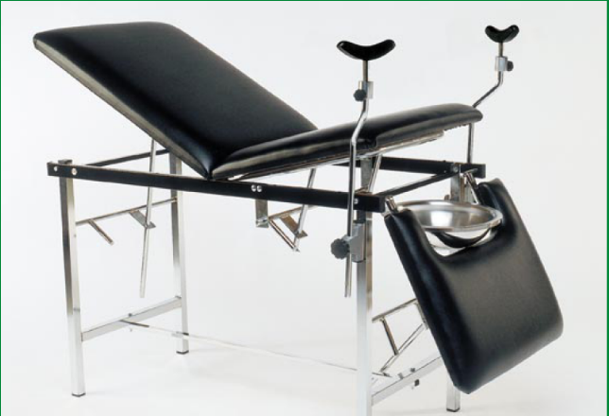
15 | -Examination couch for Gynecology, allowing auscultation of patients in sitting or lying position. | 40
15 | -Welded steel tubular frame.
15 | -Minimum diameter 25 mm, feet protected with rubber tips.
15 | -A pair of calipers round diameter 16 cm or legrests.
15 | (- Review plan: safe mattress 12 cm minimum thickness foam, fabric cover plastic type simili resistant and washable, composed of three parts including two reclining torso and leg).
15 | -Denoise skid base.
15 | -Maximum range: 200 kg.
15 | -Dimensions: L 190 x 70 x h 80 cm.
16 | VACUUM DELIVERY MANUAL + 3 SUCTION CUPS |  | 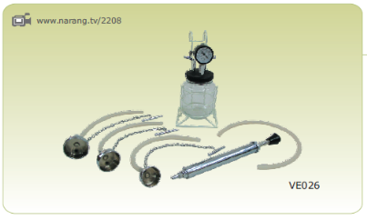
16 | · Non-electric vacuum hand pump. | 80
16 | · Complete with three suction cups soft (40, 50 and 60 mm) equipped with traction chains.
16 | · Supplied with a spare jar.
17 | BALLOON + SET NEW NES TIPS, CHILD, ADULT |  | 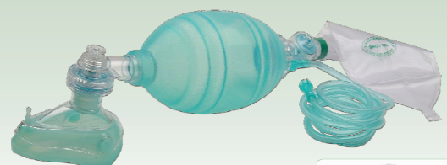  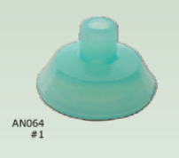  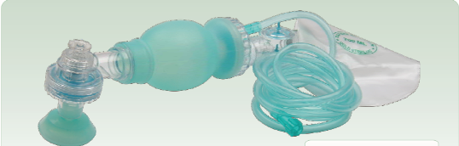
17 | For adult and paediatric ventilation: | 40
17 | · Autoclavable.
17 | · 1 ball allowing continuous handling, long life, without fatigue.
17 | · 1 patient valve with alignment keys.
17 | · adult size 2 masks.
17 | · 1 large mask size.
17 | · 2 pediatric mask.
17 | · 1 pocket of enrichment oxygen from the air.
17 | 1 silicone hose antistatic, length 200 cm, with 5 nipples of connection has a source d ' oxygen.
18 | STAINLESS STEEL BASIN | 160 | 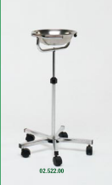
18 | stainless steel basin for medical bed
19 | BEAN | 160 | 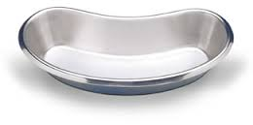
19 | · Bowl-shaped bean in 18/10 stainless steel.
19 | · Capacity: 500 ml.
20 | BOX DRESSINGS |  | 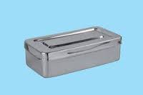
20 | 1 box stainless about 200 x 100 x 60 mm | 80
20 | 1 pair of scissors curved 10 cm
20 | 1 pair of scissors straight foams 14 cm
20 | 1 straight hemostat Péan 14 cm
20 | 1 straight hemostat Kocher 14 cm
20 | 1 clip-tweezers claws 14 cm
20 | 1 tweezers without claws 14 cm
21 | BOX INSTRUMENTS DELIVERY OF BASIC | 80 | 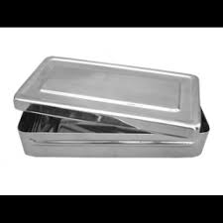
21 | Stainless steel box comprising:
21 | · 2 forceps Kocher 18 cm.
21 | · 1 urinary catheter CH12, metal.
21 | · 1 pair of scissors with episiotomy 15 cm
21 | · 1 pair of scissors straight 18 cm round-tipped.
21 | · 1 pair of scissors curved 17 cm.
21 | · 2 clips of Pandey.
21 | · 1 clamp bar.
21 | · 1 door needle Mayo Hegar 16 cm.
21 | · 1 spreader of farabeuf.
21 | · 1 clip snouts 25cm.
21 | · 1 clip Leriche 15 cm.
21 | N. B.:
21 | The instruments shall be guaranteed for the transition to steam sterilization.
21 | The instruments must have the CE marking.
22 | BOX INSTRUMENT SMALL SURGERY | 40 | 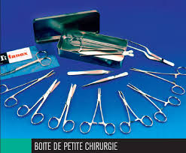
22 | · Box dimension aluminum 18 x 8 x 4 cm.
22 | · 1 pair straight chisel 14 cm.
22 | · 1 fluted probe 14 cm.
22 | · 1 needle holder mayo-hegar right of 14 cm.
22 | · 1 clip to dissect without claw 14 cm.
22 | · 1 clip to dissect with claws 14 cm.
22 | · 1 hemostat of Kocher straight without claws 14 cm.
22 | · 1 hemostat of Kocher right with claws 14 cm.
22 | · 1 clip to splinter.
22 | · 1 needle to a foreign body.
22 | NOTE:
22 | The instruments shall be guaranteed for the transition to steam sterilization.
22 | The instruments must have the CE marking.
23 | SURGICAL BRUSH | 200 | 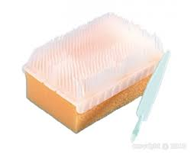
23 | Surgical type brush "Brush/sponge» surgical brushing and anchorage.
24 | TROLLEY CARE 2 SHELVES | 80 | 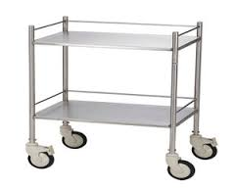
24 | · Pedestal table in stainless steel.
24 | · Stainless steel trays.
24 | · Trays dimensions: 90 x 60 cm.
24 | · The height of the top of the order of 80 cm.
24 | · Swivel wheels.
25 | CONTAINER INSULATION VACCINES | 80
25 | -1 vaccine (vaccine cold box) cooler.
25 | o capacity: 20-25 L
25 | o Conservation of vaccines more than 120 hours at 47 ° C temperature outside.
25 | -1 alcohol,-30 to + 50 ° C thermometer.
25 | -30 briquettes from cold (icepacks) 0.6 L,
25 | adapted to the cooler.
25 | vaccines (carrier) of capacity 1.7 L 3-door
26 | BOWL PLASTIC 15 L | 80 | 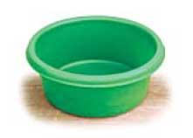
26 | -Capacity approximately 15 L
26 | -Onboard curled.
26 | Plastic
27 | FINGER STERILE | 200 | 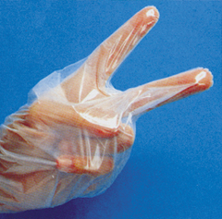
27 | Lot of 100 sterile microfibre two fingers, sterile
28 | LAMP GAS SAFETY |  | 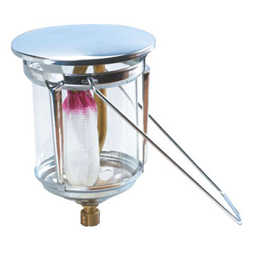
28 | -Lamp gas protected or plastic glass and transport and hanging handle. | 40
29 | ROUND KNIFE + BLADE | 80 | 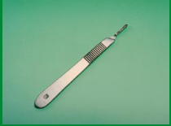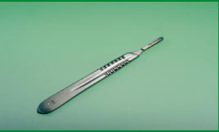  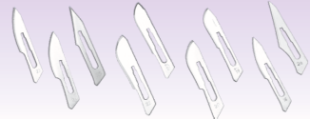
29 | Rounds 3 and 4 game
29 | Set of 5 sterile blades of each of the following numbers:
29 | N ° 11
29 | N ° 15
29 | N ° 23
30 | POT PRESSURE | 40 | 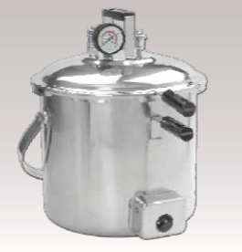
30 | -Tank for sterilization under pressure of instruments or needles.
30 | Sterilization on gas, electric stove.
30 | Capacity: 9 litres.
30 | -Pressure safety valve.
30 | -Audible pressure.
30 | -Pressure gauge 0-4 bar.
30 | -Baskets for needle and syringe and instruments.
31 | TRAY 240 X 160 X 50 STAINLESS STEEL INSTRUMENTS | 200 | 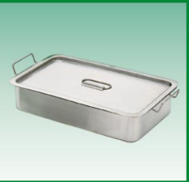
31 | -Stainless steel tray with lid in stainless steel 18/8.
31 | -Dimensions: 24 x 16 x 5 cm.
32 | POISSONNIÈRE STAINLESS STEEL |  | 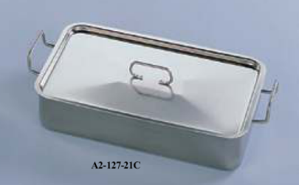
32 | -For sterilisation by boiling. | 40
32 | -Made of stainless steel.
32 | -With handle embossed lid.
32 | -Dimensions: 40 x 20 x 10 cm
33 | SQUEEZE BOTTLE A LIQUOR | 40 | 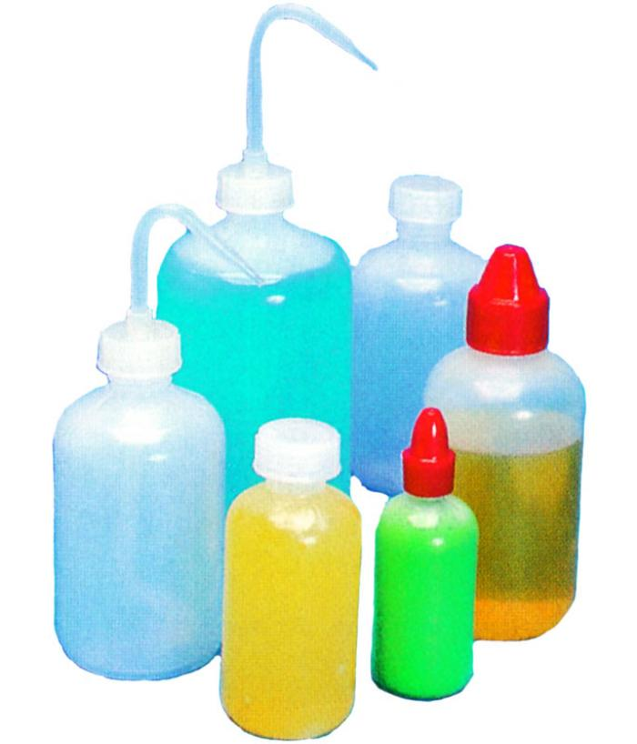
33 | -Squeeze bottle polyethylene flexible, impact resistant, perfectly waterproof.
33 | -Neck bottle-shaped, adjustable hose.
33 | -Capacity: 500 ml.
34 | RECHAUD GAS 2 BURNERS + GAS BOTTLE | 40 | 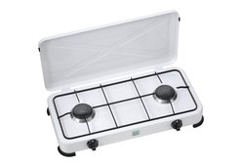
34 | -Stove two burner with adaptation of the gas hose nozzle
35 | MIXED GAS/ELECTRIC REFRIGERATEUR\CONGELATEUR | 40
35 | Horizontal refrigerator for the storage of vaccines in integrated health posts lack electricity.
35 | - Operating gas/electricity
35 | -Compression or absorption, CFC-free.
35 | -Tropicalized operation, up to 45 ° C outside.
35 | -Combining the vaccine storage and freezer for ice pack
35 | o storage 20 L capacity
35 | o capability on the order of 15 L pack ice freezer
35 | -Arranged for stockpiling vaccines and the ice pack
35 | -With internal reading control thermometer.
35 | -Maximum gas consumption: 0.6 kg/day
35 | - Attention: indicate the refrigerator gas consumption
35 | - Note : the appliance is used in a first time to operate the gas and possibly a second time on electricity by solar energy.
35 | -Spare parts.
35 | -Supplied with 2 bottles of gas GM
36 | SET OF 3 SIZES VAGINAL SPECULUM | 80 | 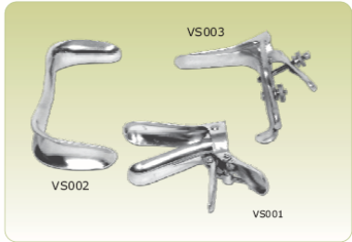
36 | -3 type Cusco vaginal specula games.
36 | -Made of stainless steel 18/10.
36 | -Non-removable Assembly.
36 | Diameters: 16, 30, 38 mm
37 | STEHOSCOPE PINARD ALUMINIUM | 80 | 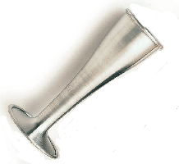
37 | Pinard aluminum model
38 | DRUM A DRESSING | 80 | 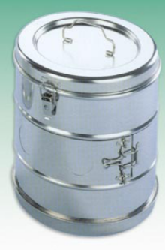
38 | -For sterile and cotton compresses.
38 | -Made of stainless steel 18/10.
38 | -With sides and lid handle.
38 | Diameter of the order of 190 mm, height of the order of 150 mm
39 | ROD RIBBON | 40 | 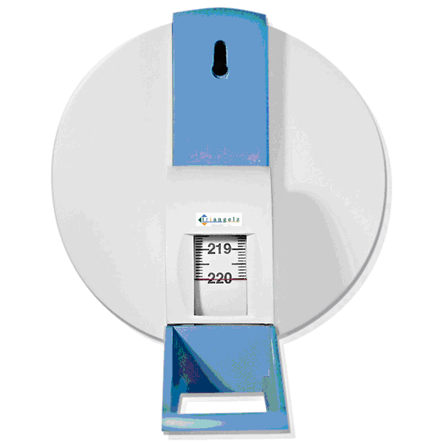
39 | -Rod tape flexible to attach to the wall 2 m of height.
39 | -Wide ribbon down to 50 cm from the ground.
40 | Beds + mattresses | 80
 | Medical beds to a fixed section with feet on skates
 | Epoxy coating
 | Bottomplate in wire mesh
 | Head and footboard to vertical bars
 | Padded mattress with washable and fire-resistant coating
 | Dimensions: 200 X 85 X 50 (h) cm
 | Marking: This Medical
41 | DOOR SERUM MOBILE 2 HOOKS | 120 | 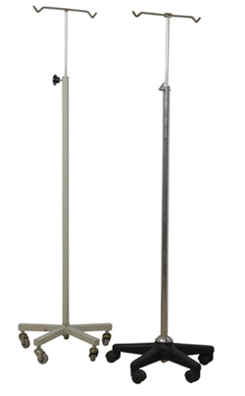
41 | -2 hooks doors stainless steel jars.
41 | -Height adjustable up to 200 cm stainless steel column.
42 | OFFICE - 3 DRAWERS |  | 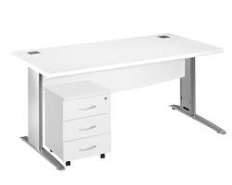
42 | Tubular frame in painted steel.
42 | Sheet 8/10 steel.
42 | Shelf metal thickness 30 mm, dimensions W 120 x 80 x h 75 cm. | 80
42 | Side panels and bottom panel in painted steel.
42 | Base protector pads.
42 | 1 soundproofed metal casing consisting of:
42 | 3 sliding on bearings slide storage drawers.
43 | CHAIR OFFICE | 80 | 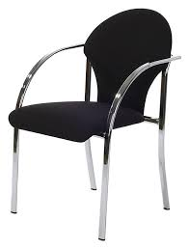
43 | Assisi 35 x 35 cm and folder curved metal.
43 | Seat height: 50 cm.
43 | Sheet steel 8/10.
43 | Base protector pads.
43 | Stackable.
44 | VISITOR CHAIR | 400 | 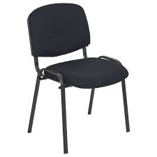
44 | · Robust, and Stackable chair without armrests.
44 | · Frame fixed in epoxy coated metal tubes.
44 | · Seat mounted on 4 legs
44 | · Seat and backrest with padding in expanded material and fabric coating resistant and washable
44 | · Seat dimensions: width and depth of the order of 45 cm.
44 | · Seat height: 45 cm.
45 | CABINET OFFICE 3 SHELVES METAL | 80 | 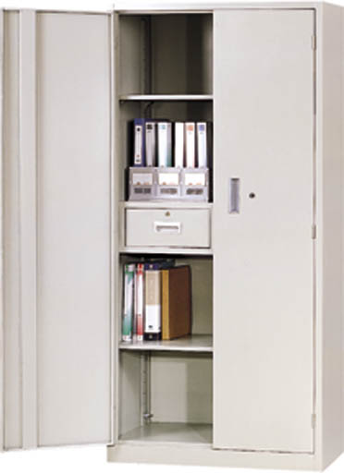
45 | Wardrobe with 2 doors.
45 | Sheet steel 8/10.
45 | 4 shelves of storage for hanging folders, fixed height.
45 | Latches and lock with padlock closure.
45 | Supplied with padlock and 2 keys set.
45 | Base protector pads.
45 | Dimensions: w 100 x d 40 x h 185 cm.
45 | The metal surfaces must be scraped before anti-rust treatment and passage of the spray paint.
46 | CHEST FORT | 40 | 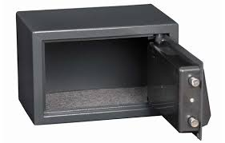
46 | Small model
47 | SHELVING METAL | 40 | 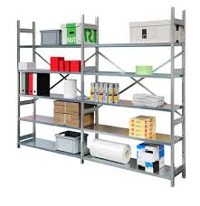
47 | -Modular metal shelving steel bottomless.
47 | Length 5 m, height 200 cm, depth 40 cm.
47 | -Amounts in sheet steel, reinforced.
47 | -Metal cross rods for reinforcement of all
47 | -Five full metal shelves fixed.
47 | -Uploaded by Tablet minimum 140 kg.
47 | -The bottom shelf is 5 cm from the ground.
47 | -Denoise skid base.
48 | 1200 X 800 TABLE | 40 | 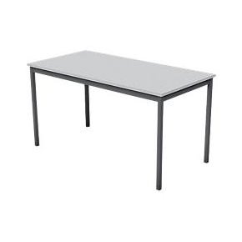
48 | Plateau and fixed metal legs.
48 | -Sheet steel 10/10 minimum.
48 | -Denoise skid base.
48 | -Dimension shelf: L 120 x 80 cm
48 | -Height: 75 cm.

